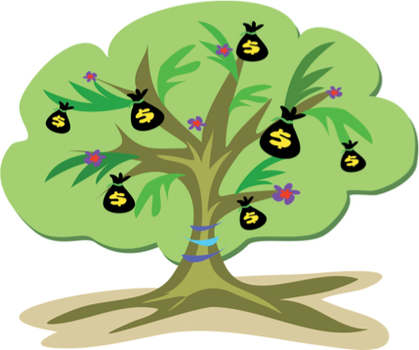
Participate in these FREE
programs and earn dollars for Quail Run!

Money CAN Grow on Trees!
Quail Run Learning Fund
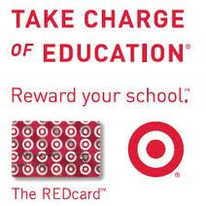
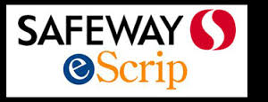
Corporate Matching

Program | Description | How Do I Participate?
Corporate Matching | Double Your Donations! Your employer may match your donations made to the QRLF. | Check out our website for details on this program or stop by the QRLF table at registration if you have questions.  http://www.qres.srvusd.net/learningfund
Box Tops for Education | Turn in Box Top coupons from your grocery items and help to raise money! | Please continue to clip and save Box Tops. Each one earns 10¢ for Quail Run. Submit package originals only, and please check the expiration dates. Collect them in a baggie or envelope and give them to your teacher or turn them into the office.
eScrip (Safeway Club Card) | eScrip contributes a percentage of what you spend at Safeway to the QRLF. Register your Safeway club card to designate Quail Run as recipient of these contributions! | Register your Safeway card for use in the program. Click here to renew eScrip – www.escrip.com  Note that eScrip must be re-newed yearly for Quail Run to receive contributions. Make sure to specify your designated recipient as “Quail Run Elementary” or Group ID #500002339
Amazon Associates | Earn up to 15% of your Amazon purchase for our school | Shop Amazon through the Quail Run Amazon Associates link
Target Red Card | Target will donate 1% of your REDcard purchase made at Target and Target.com to Quail Run! | Go to www.target.com and click on the section Take Charge of Education and register your Target Red Card.

